Power Automate final assessment.

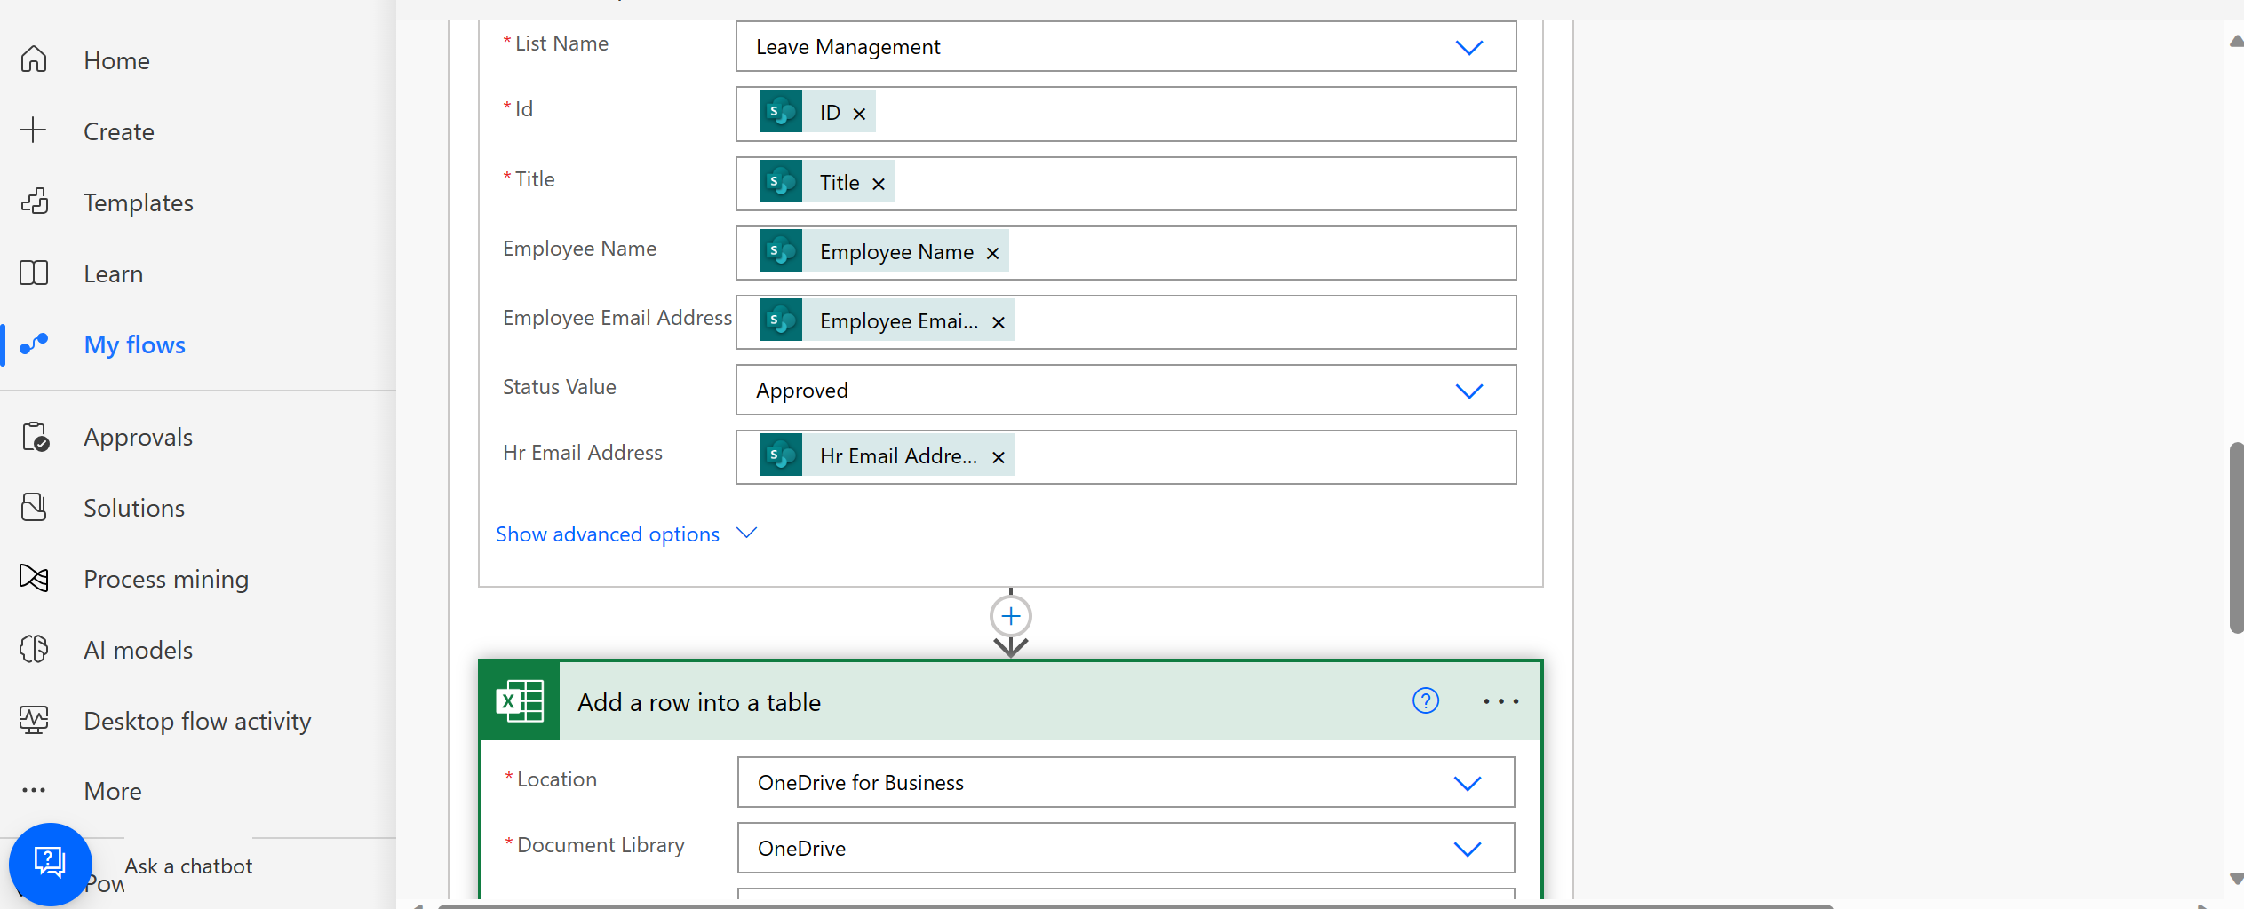

Sharepoint list for submitting leave requests

Excel worksheet for tracking leave requests

Employee notification of the final status

